DBMS – SELLER AND INVENTORY MANAGEMENT
TITAN EYE – EYEWEAR E-COMMERCE DATABASE SYSTEM

1. Database Design
1.1 Seller Table
Attribute | Data Type | Constraint
Seller_ID | NUMBER | Primary Key
Seller_Name | VARCHAR2(150) | NOT NULL
Email | VARCHAR2(150) | —
Phone_Number | VARCHAR2(15) | —
Address | VARCHAR2(250) | —

1.2 Inventory Table
Make another table:
Attribute | Data Type | Constraint
Inventory_ID | NUMBER | Primary Key
Seller_ID | NUMBER | Foreign Key
Product_ID | NUMBER | Foreign Key
Stock_Quantity | NUMBER | —
Product_Status | VARCHAR2(20) | —

2. Table Relationships
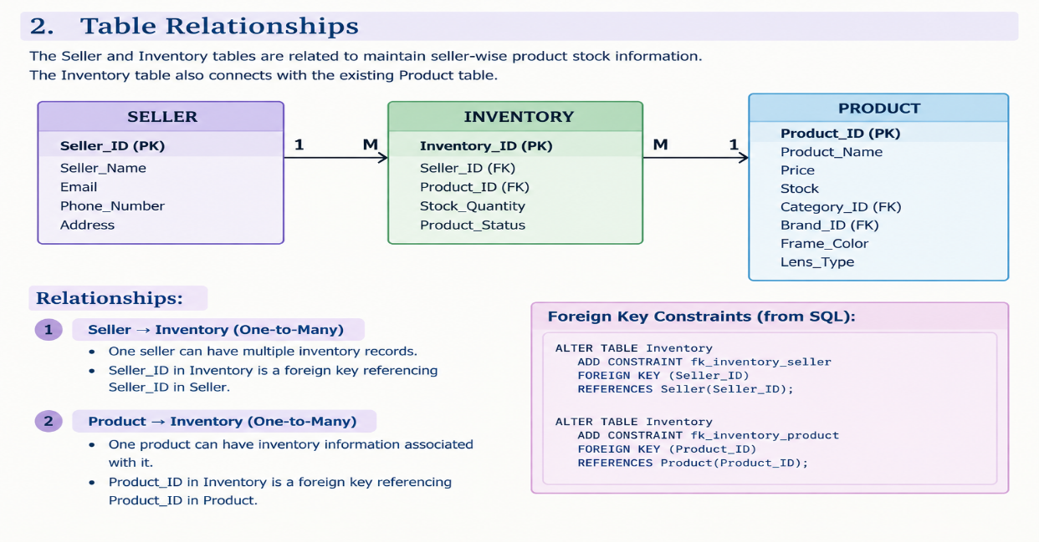

3. Table Creation
3.1 Create Seller Table
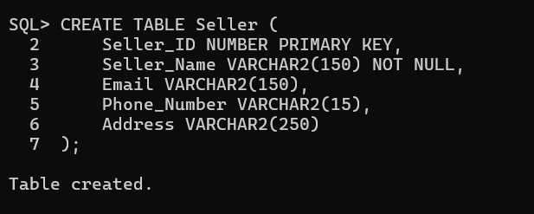
3.2 Create Inventory Table

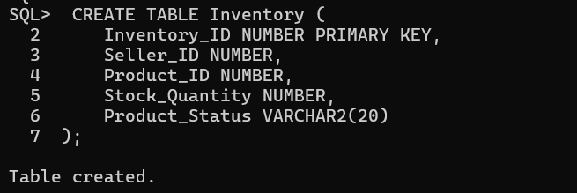
3.3 Establish Foreign Key Relationships
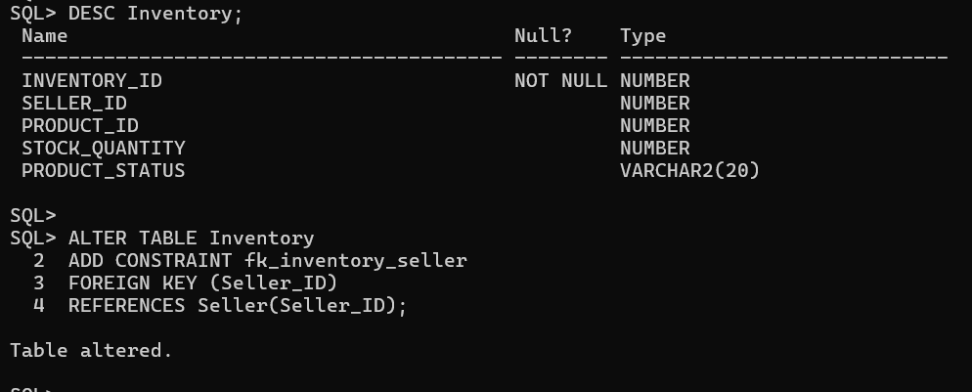
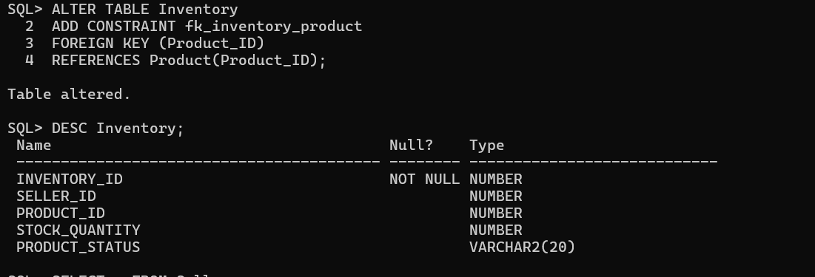

4. Seller Data Insertion
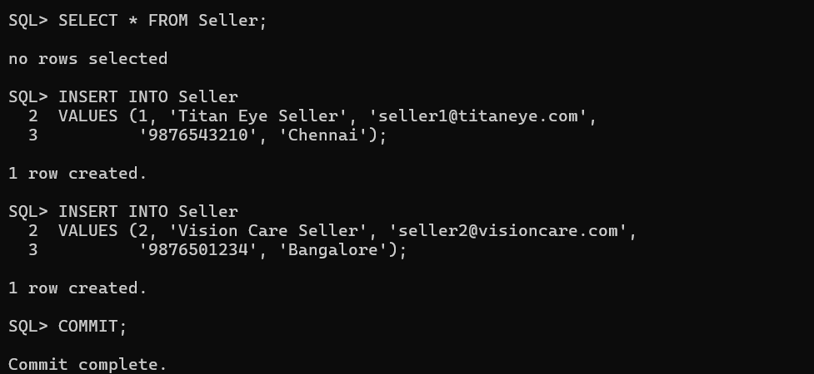
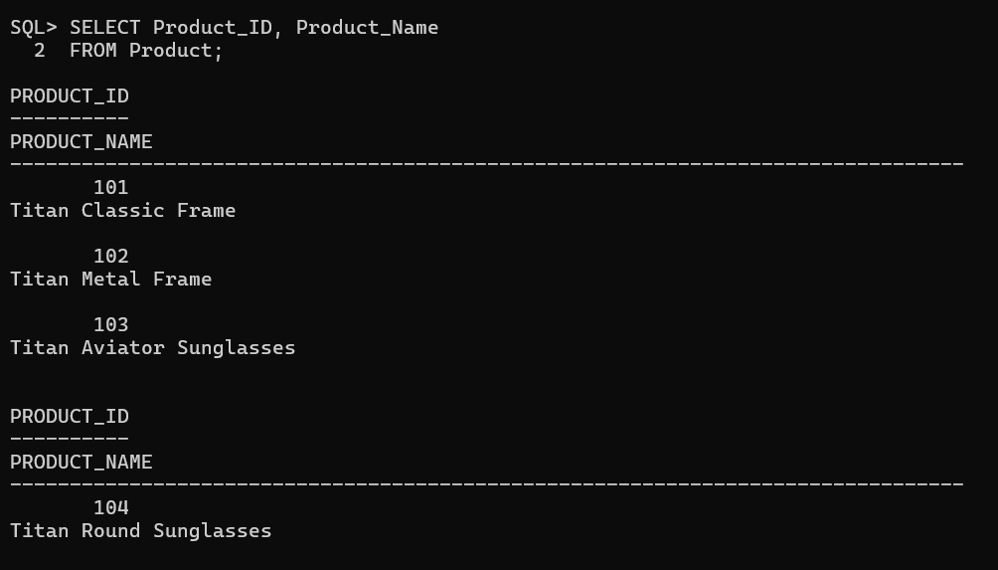
5.Inventory Data Insertion
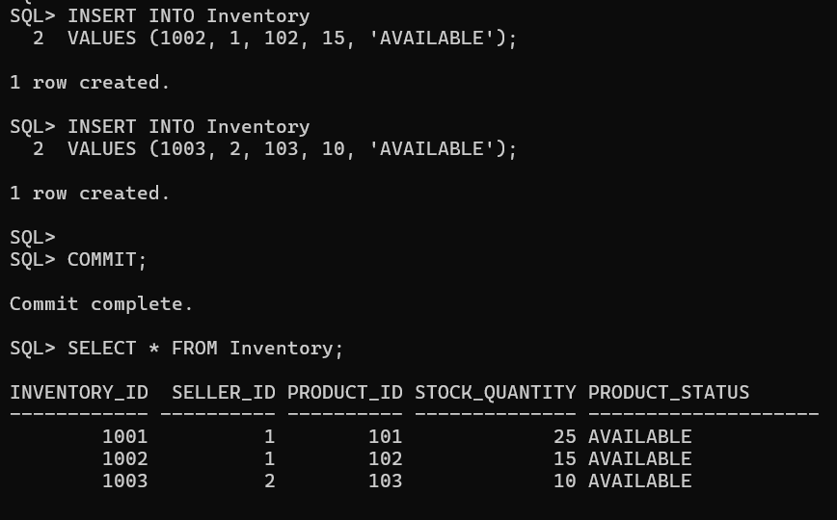

6. Inventory Update
6.1 Update Stock Quantity
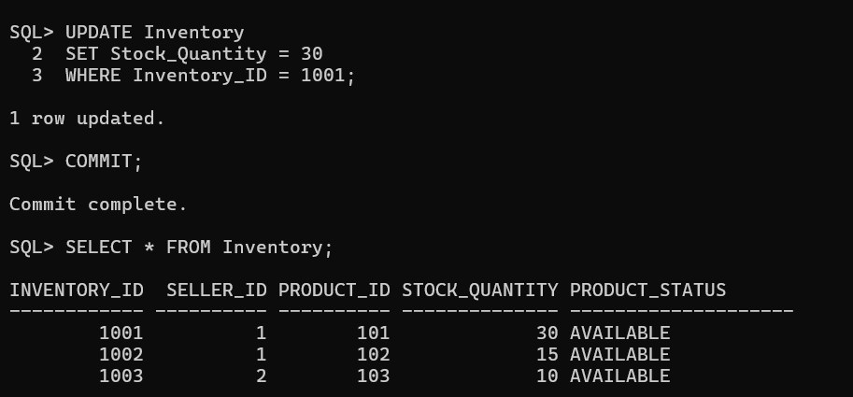
6.2 Update Product Status
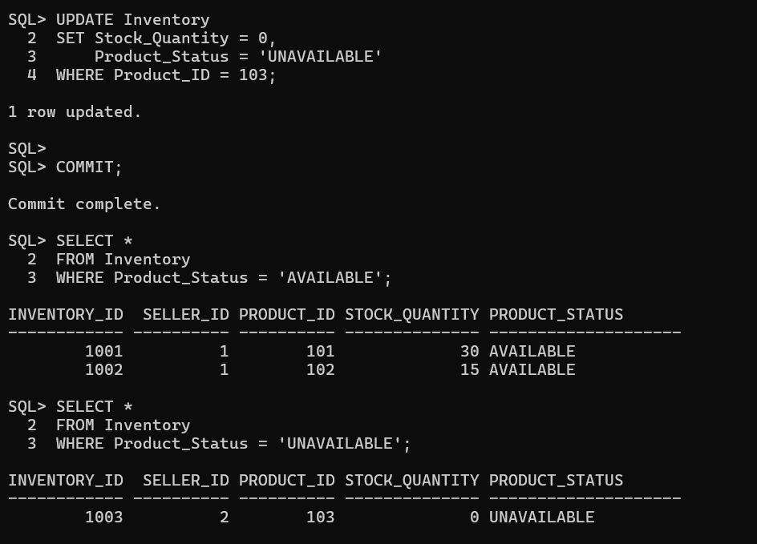
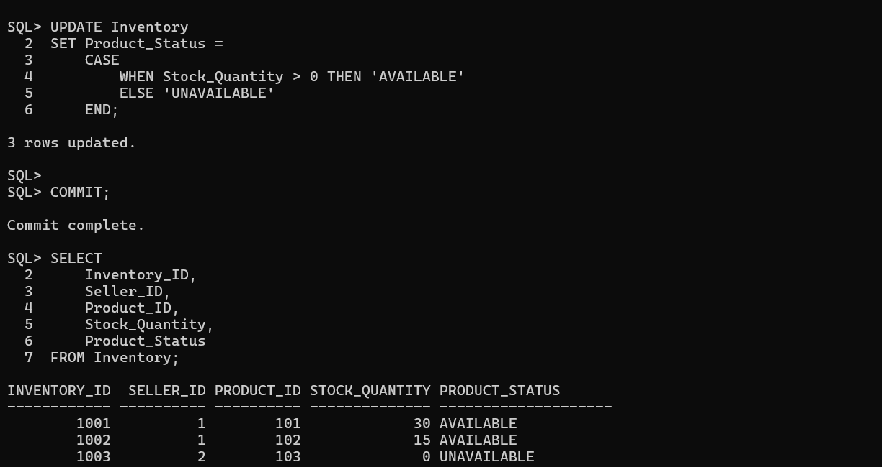
7. Seller Product Information
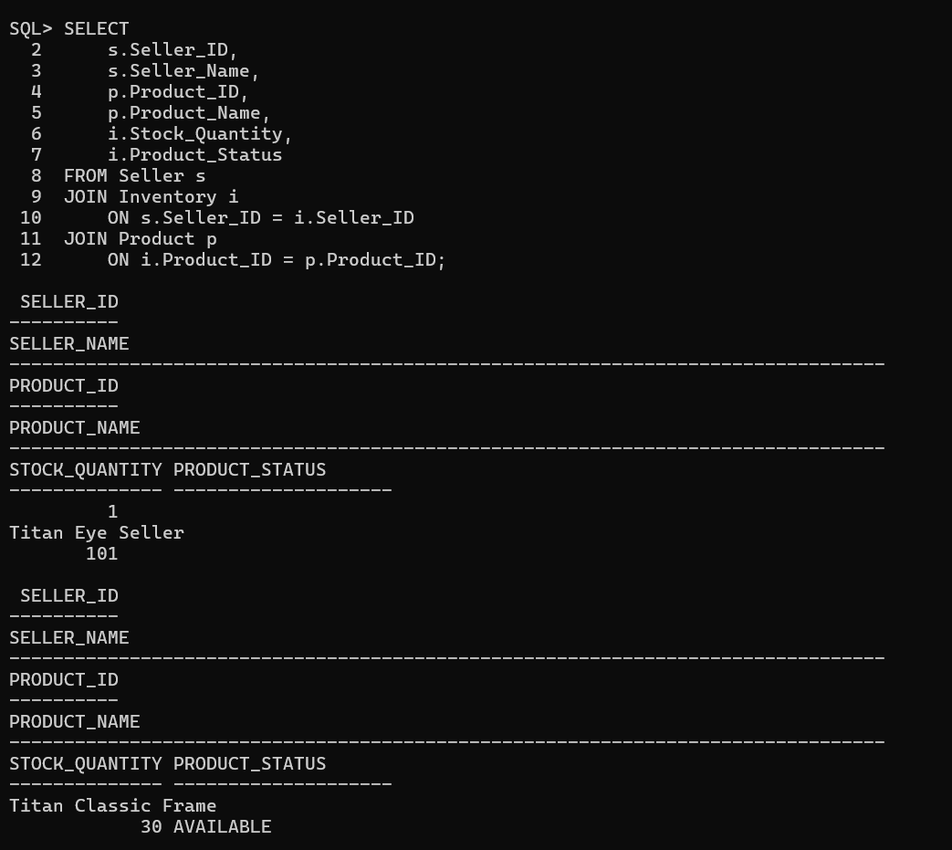
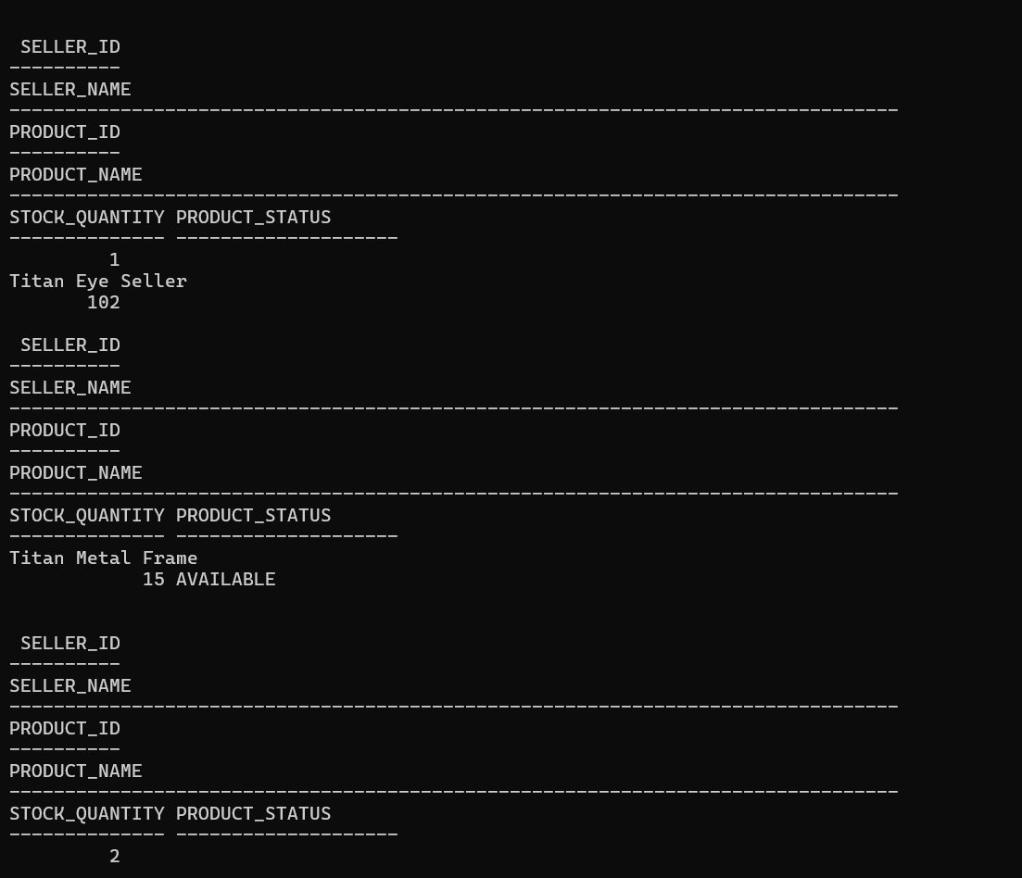
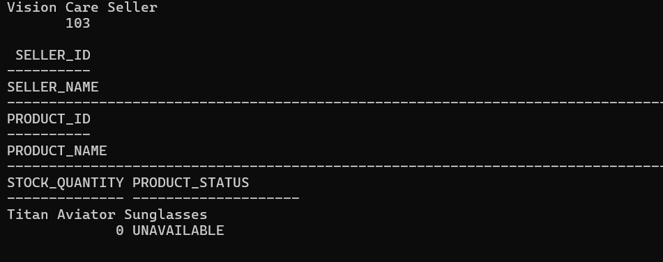

8. Inventory Status
8.1 Display Available Products

8.2 Display Unavailable Products

